The HIARC Bulletin

March 2023 Edition

Newsletter of the Harris-Intersil Amateur Radio Club

Club Meetings: Second Thursday of each month at Meemaw’s Barbecue on Babcock Street between Palm Bay Road and Port Malabar Road. Supper is at 5:30 PM, business is at 6:30 PM. Prizes at 7:45 PM. Our programs start around 7:00 PM. Meeting ends by 8:00 PM. As some members have allergies, we kindly ask that you refrain from wearing fragrances. Thanks.

Repeaters: K4HRS, 145.47 Mc, tone 107.2 cycles. Down for the moment, being moved to the Turkey Creek Tower.

Nets:

Open to everyone:

- South Brevard Emergency Net: Thursdays at 7:00 PM. 146.61 Mc. In event of repeater failure 146.85 Mc and or 146.58 Mc simplex.

- Skywarn Net: Thursdays, after the SBEN net / 7:30 PM or so, 146.61 Mc

- Palm Bay Informal Net: 8 PM Thursdays on 147.255 Mc.

- Medical Complaint Nets: evenings 3.6 to 4.0 Mc.

HIARC Web Site: www.qsl.net/hiarc. Website administrator; Jim Tonti, KC7SSW

Officers: President: Francis Parsche (“Butch”), WA4AQV
Treasurer: Pat Reilly KA4ZEC
Secretary: Open
Repeater Chairman: Clyde KD8AN
Program Chairman: Open
Field Day Chairman: Open
Sunshine Chairman: Open
Club Jester: Ken N8KH

Annual Membership:

Annual dues are $12.00. You can join at the meeting or send a check to:

HIARC Treasurer
Pat Reilly, KA4ZEC
1985 Howell Lane
Malabar, FL 32950

We are on a calendar year dues system with annual dues due in June. Dues are prorated by a dollar a month. If you join in April dues are $2.00 to get to June.

Send me your email address to receive the newsletter: francis.parsche@l3harris.com

Select Hamfests

- 3-18-23, Stewart, www.stuarthamfest.com

Ham Radio Lunches:
- Every Friday, 11:00 AM till 1:00 PM or so, Golden Corral on Palm Bay Road in Palm Bay. Talk in on 146.61 Mc repeater.
- Every Friday, 11:00 AM till 1:00 PM or so, Crystal Buffet on 192. Talk in on 146.61 Mc repeater.
- Once a month, the Saturday after the PCARS meeting, Sarno Restaurant and Pizzaria, 11:00 AM. Talk in 146.61 repeater. This restaurant is at the corner of Sarno Road and Croton Road.
February 2023 HIARC Meeting And Program

When: The next HIARC meeting is Thursday March 9.

Where: Meemaws Barbecue on Babcock Street.

Agenda:

5:30 PM dinner
6:30 PM business
6:45 PM prizes
7:00 PM program

Program: “The TBY-8 military manpack transceiver of World War Two and the Navajo Codetalkers” by Butch WA4AQV
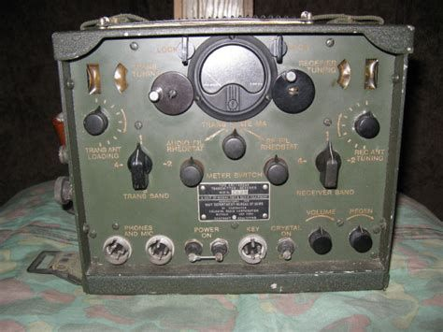

TBY-8 Breakie Backie

As a bonus John Lundberg W2TX will be joining us and may update us on his precision timing projects. We have not seen John in several years. Welcome back John.

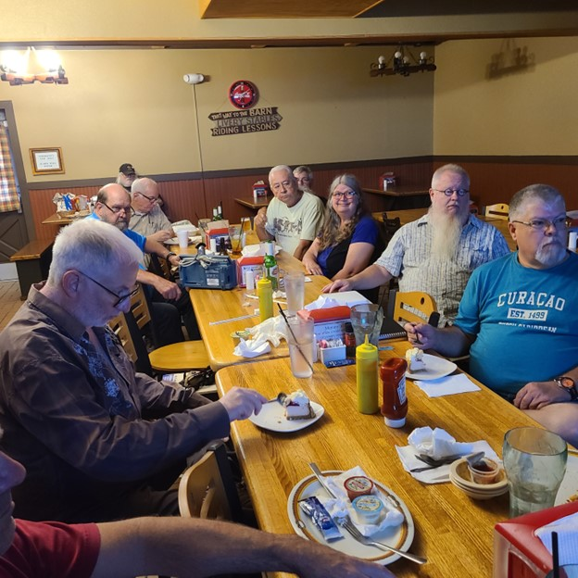

A Recent HIARC Meeting

Bouvet DX’pedition

By now the 2023 Bouvet Island 3Y0J DX’pedition is over. Most people locally could not hear hear them. Bouvet is a very remote uninhabited island near Antarctica in the south Atlantic or nearly so.

Far as I can see the Bouvet operating site and antennas were located on the southwast side of Bouvet Island with mountains and glaciers blocking the field of view toward much US, or at least not providing a desireable ground reflection area. Operating on 40 or 80 meters might have permitted high take off angle radiation, clearing the mountain blockage, to have been returned by the ionosphere for multiple hop propagation short path the US. But the expedition never operated lower in frequency than the 10.1 Mc that I know of. Long path propagation over the South Polar Region was lossy due to continuous daylight there this time of year.

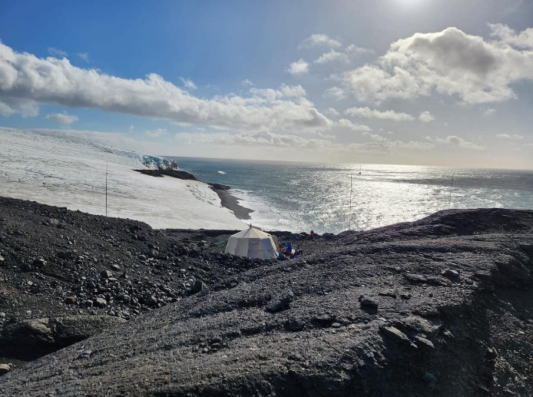

Bouvet 2023 Operating Site

A few local stations here in Brevard were able to work Bouvet with very large antennas. I only heard Bouvet on 20 meter code using a remote receiver in Paraguay.

None of this is to find fault with the Bouvet Expedition. Setting up any station there is difficult. The radio operators had to pull themselves from the boat to shore on a rope attached to a buoy at sea, wearing an exposure suit to deal with the freezing seas. Then equipment had to carried up an 800 foot rise. Everyone is coming back in one piece most importantly.

Electric Cars And AM Radio

No new Tesla car includes AM radio reception. Electric cars can be capable of severe electromagnetic interference at lower frequencies. Ford is keeping AM radio in it’s new F150 electric pickup. 150 million Americans listen to some AM radio each day. Interesting to see how electric cars and amateur radio get along?

Amateur Radio Balloon Shot Down

Bet you have been wondering when this was going to happen? Amateur radio balloon shot down over Canada: The US Airforce may have shot down an Amateur Radio Pico Balloon over Canada (rtl-sdr.com) Sidewinder missiles cost $400,000.00 each.

Telephone Line Interference

AT&T brought fiber to my home / premises on February 6, 2023 In fact the fiber runs all the way to a small box on my desk. This has ended 23 years of HF radio interference from the previous AT&T broadband over unshielded telephone line internet service in my neighborhood. Progress at last.

Butch WA4AQV

New Repeater Tone

The 146.61 Mc repeater now requires a 107.2 cycle tone to serve you better by cutting down on interference which was keying the repeater up.

