The HIARC Bulletin

May 2023 Edition

Newsletter of the Harris-Intersil Amateur Radio Club

Club Meetings: Second Thursday of each month at Meemaw’s Barbecue on Babcock Street between Palm Bay Road and Port Malabar Road. Supper is at 5:30 PM, business is at 6:30 PM. Prizes at 7:45 PM. Our programs start around 7:00 PM. Meeting ends by 8:00 PM. As some members have allergies, we kindly ask that you refrain from wearing fragrances. Thanks.

Repeaters: K4HRS, 145.47 Mc, tone 107.2 cycles. Down at the monent.

Nets:

Open to everyone:

- South Brevard Emergency Net: Thursdays at 7:00 PM. 146.61 Mc. In event of repeater failure 146.85 Mc and or 146.58 Mc simplex.

- Skywarn Net: Thursdays, after the SBEN net / 7:30 PM or so, 146.61 Mc

- Palm Bay Informal Net: 8 PM Thursdays on 147.255 Mc.

- Medical Complaint Nets: evenings 3.6 to 4.0 Mc.

HIARC Web Site: www.qsl.net/hiarc. Website administrator; Jim Tonti, KC7SSW

Officers: President: Francis Parsche (“Butch”), WA4AQV
Treasurer: Pat Reilly KA4ZEC
Secretary: Open
Repeater Chairman: Clyde KD8AN
Program Chairman: Open
Field Day Chairman: Open
Sunshine Chairman: Open
Club Jester: Ken N8KH

Annual Membership:

Annual dues are $12.00. You can join at the meeting or send a check to:

HIARC Treasurer
Pat Reilly, KA4ZEC
1985 Howell Lane
Malabar, FL 32950

We are on a calendar year dues system with annual dues due in June. Dues are prorated by a dollar a month. If you join in April dues are $2.00 to get to June.

Send me your email address to receive the newsletter: francis.parsche@l3harris.com

Select Hamfests

- 4-15-23, Melbourne, PCARS swapmeet, Melbourne fire Training Center, 1850 Hugher Road Melbourne FL 32935. Starts about 9 AM, some may come earlier. Talk in 146.61 repeater, tone 107.2.

Ham Radio Lunches:
- Every Friday, 11:00 AM till 1:00 PM or so, Golden Corral on Palm Bay Road in Palm Bay. Talk in on 146.61 Mc repeater.
- Every Friday, 11:00 AM till 1:00 PM or so, Crystal Buffet on 192. Talk in on 146.61 Mc repeater.
- Once a month, the Saturday after the PCARS meeting, Sarno Restaurant and Pizzaria, 11:00 AM. Talk in 146.61 repeater. This restaurant is at the corner of Sarno Road and Croton Road.
February 2023 HIARC Meeting And Program

When: The next HIARC meeting is Thursday May 11, 2023.

Where: Meemaws Barbecue on Babcock Street.

Agenda:

5:30 PM dinner
6:30 PM business
6:45 PM prizes
7:00 PM program

The May HIARC program will be on the April 17, 18 IEEE Wamicon Microwaves Conference that was held in Melbourne FL. We will learn what is new in the field and useful to amateur radio.

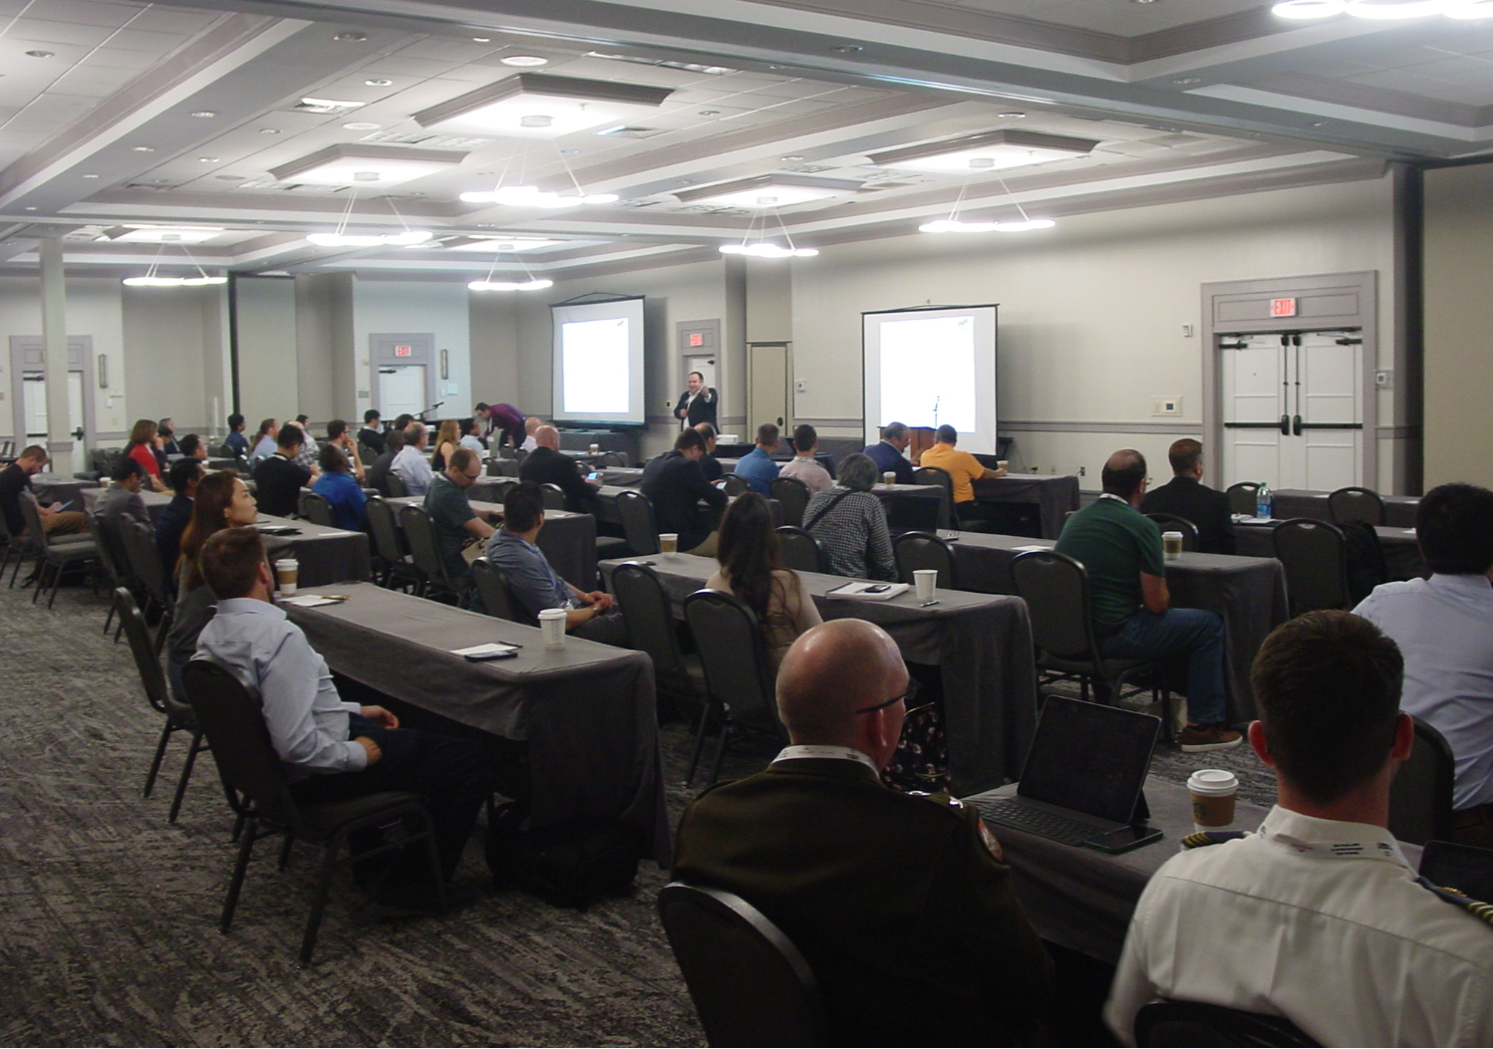

2023 WAMICON IEEE Conference

The 145.47 Mc Repeater

The HIARC 145.47 Mc. repeater has been down for 12 months. We lost the Rialto repeater site 12 months ago. The matter was brought up for discussion at the last meeting. At the meeting there was no interest in finding another site or in doing the duplexer engineering needed to share the Turkey Creel Tower site with the 146.85 repeater. At this point it looks like the 145.47 repeater will remain off the air indefinitely.

Older QST Access

Older issues of QST magazine can be downloaded at https://worldradiohistory.com/QST.htm?force_isolation=true

