The HIARC Bulletin

November 2023 Edition

Newsletter of the Harris-Intersil Amateur Radio Club

Club Meetings: Second Thursday of each month at Meemaw’s Barbecue on Babcock Street between Palm Bay Road and Port Malabar Road. Supper is at 5:30 PM, business is at 6:30 PM. Prizes at 7:45 PM. Our programs start around 7:00 PM. Meeting ends by 8:00 PM. As some members have allergies, we kindly ask that you refrain from wearing fragrances. Thanks.

Repeaters: K4HRS, 145.47 Mc, tone 107.2 cycles. Down as the site ownership changed.

Nets:

Open to everyone:

- South Brevard Emergency Net: Thursdays at 7:00 PM. 146.61 Mc. In event of repeater failure 146.85 Mc and or 146.58 Mc simplex.

- Skywarn Net: Thursdays, after the SBEN net / 7:30 PM or so, 146.61 Mc

- Palm Bay Informal Net: 8 PM Thursdays on 147.255 Mc.

- Medical Complaint Nets: evenings 3.6 to 4.0 Mc.

HIARC Web Site: www.qsl.net/hiarc. Website administrator; Jim Tonti, KC7SSW

Officers: President: Francis Parsche (“Butch”), WA4AQV
Treasurer: Pat Reilly KA4ZEC
Secretary: Open
Repeater Chairman: Clyde KD8AN
Program Chairman: Open
Field Day Chairman: Open
Sunshine Chairman: Open
Website Chairman: Open
Club Jester: Ken N8KH

Annual Membership:

Annual dues are $12.00. You can join at the meeting or send a check to:

HIARC Treasurer
Pat Reilly, KA4ZEC
1985 Howell Lane
Malabar, FL 32950

We are on a calendar year dues system with annual dues due in June. Dues are prorated by a dollar a month. If you join in April dues are $2.00 to get to June.

Send me your email address to receive the newsletter: francis.parsche@l3harris.com

Select Hamfests

Orlando, February 9 – 11 2023 www.hamcation.com

Stewart, March 19, 2023 www.mcaraweb.com

Ham Radio Lunches:
- Every Friday, 11:00 AM till 1:00 PM or so, Golden Corral on Palm Bay Road in Palm Bay. Talk in on 146.61 Mc repeater.
- Every Friday, 11:00 AM till 1:00 PM or so. Crystal Buffet on W. New Haven (US192) across from the Melbourne Mall. Talk in on 146.61 Mc repeater.
- Once a month, the Saturday after the PCARS meeting, Sarno Restaurant and Pizzeria, 11:00 AM. Talk in 146.61 repeater. This restaurant is at the NW corner of Sarno Road and Croton Road.
September 2023 HIARC Meeting And Program

When: The next HIARC meeting is Thursday November 9, 2023.

Where: Meemaws Barbecue on Babcock Street.

Meeting Agenda:

5:30 Supper

- They have Lake Okeechobee catfish, steaks, ribs etc. Don’t forget to tip as we meet for free.

6:30 Business Meeting

- Officer reports

- Old business

  - Trade questions about the 145.47 Mc repeater
  - Wise cracks

- New Business

  - Need new HIARC website chair

6:45 Jokes, ticket sales

6:50 Door prizes

7:00 Program: “A Two Band J Pole Antenna”. Slides, and show and tell demo.

7:50 Adjourn

Presidents Message:

10 meters is open every day now. Solar flux has been between 130 and 190. Way up from the 60’s at solar minimum. Double the solar flux double the maximum usable frequency (MUF).

Work to the east in the morning. Work to the west in the afternoon. Surprise directions now and then.

The 2023 Melbourne Hamfest was a success. All the tables were sold out.

Free Technician License Class

Free two-day technician license class. Starts at 8 AM on Saturday November 11 and continues November 12 at 9 AM on Sunday November 12. Runs most of the day each day. Location is Melbourne Fire Department Training Center. Bring a bag lunch. License tests will be the next weekend November 18.

Please sign up ahead at classes@pcars.org. Or you can call Dennis K3AAX at (321) 259-8627. Do let them know ahead of time.

902 Mc Worked All States

Al W5LUA has achieved the first ever worked all states award on the 902 MHz band.
Congratulations Al!

73,
Ken N8KH

Fair Radio Sales Closing

Fair Radio Sales is closing. Boo hoo.

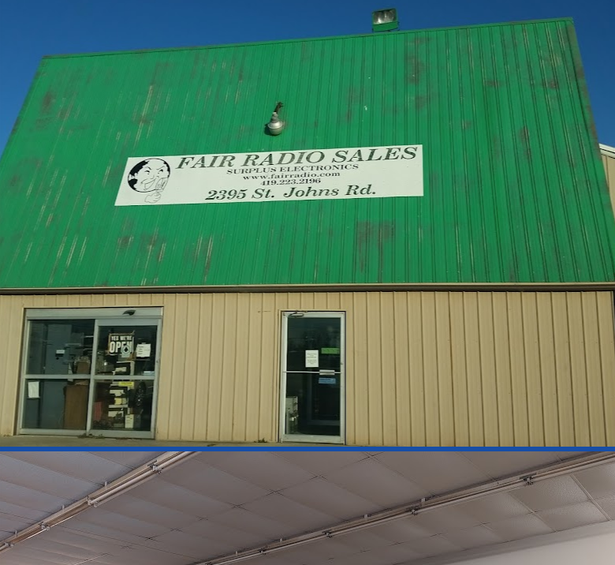

Fair Radio is the last of the war surplus radio dealers. They started in 1947 and are located in Lima Ohio an old industrial town. Most of the surplus dealers have had trouble finding someone to pick up the business when the first owner retired. It is hard to learn the surplus business without working in it. There is a lot of uncertainty in surplus. The more modern military radio surplus gets smashed up to prevent adversaries from using it. Sometimes it gets left behind in Afghanistan also, maybe there is a surplus radio dealer over there now?

Fair Radio still has a lot of stuff left so stock up while you can. Cash and carry if you want to go there. They will take offers I hear. Website: www.fairadio.com

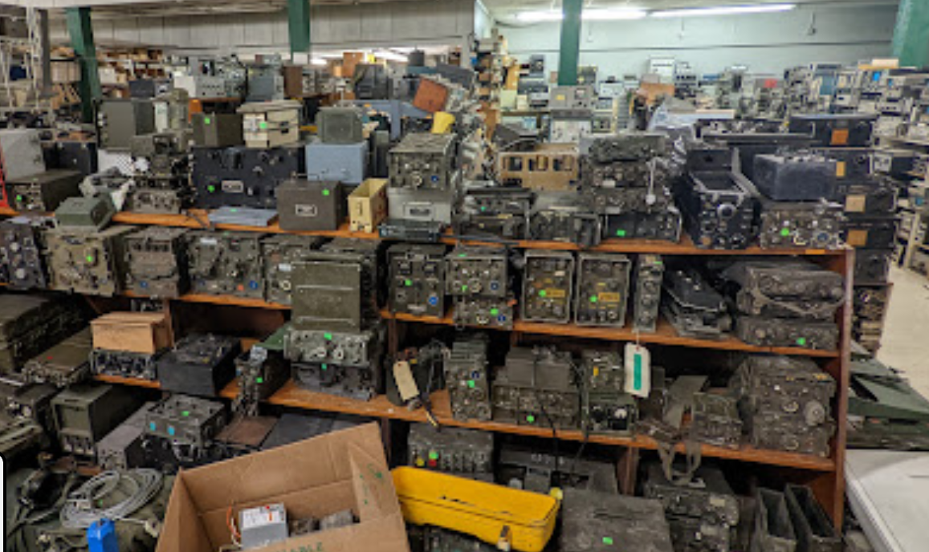

Lots of Good Surplus

Radio Astronomy And The Other Ionosphere

Remember Voyager 1 and Voyager 2? The interplanetary space probes that took pictures of Jupiter, Saturn, Uranus and Neptune? Launched in the 1970’s they are now way out there beyond the influence of the sun, past the plasmapause, past the heliosheath, in the “interstellar medium”. The new discovery-confirmation of an interstellar medium was made by Voyager 1 on August 25, 2012 at a distance from 18 billion miles / 121 astronomical units. Interstellar medium - Wikipedia. Another ionosphere was quietly discovered at the same time!

How’s that? The interstellar medium is plasma. Plasma is what makes ionospheres work. Waves bend out of it. The plasma frequency in interstellar space was found to be about 100 kilocycles. Reflections off the interstellar ionosphere are possible near and below 100 kHz frequency. We have a second interstellar ionosphere some 18 billion miles out here!

This new interstellar ionosphere will be difficult to use from earth as our own earth ionosphere tends to block waves below 2 to 12 Mc. And wave spreading loss getting there is some 280 decibels.

Perhaps the biggest practical impact of the interstellar plasma discovery is that a lower frequency bound may be defined for radio astronomy. Signals of interstellar origin may not be likely below 100 kHz due to the cloaking effect of the interstellar plasma.

While radio astronomy by spacecraft or on the far side of the moon below 2 MHz astronomy at such frequencies is possible, radio astronomy below 2 Mc is unexplored or nearly unexplored due shielding by the earth ionosphere. Lower radio astronomy I have heard of was Grote Reber’s efforts near 2.079 Mc from Tasmania. Grote used a large wire dipole array. Tasmania was picked because the latitude meant a lower ionosphere cutoff frequency. The ionosphere is less ionized near the poles.

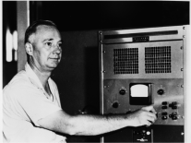

Grote Reber, W9GFZ Radio Astronomer

There is an annual amateur radio radio astronomy conference in Green Bank WV every summer.

More Amateur Radio Signal Bandwidth

Fantastic news!
The FCC is going to consider removing the outdated amateur band signal baud rate limitation:
https://Docs.FCC.gov/public/attachments/DOC-397992A1.pdf

If we can use a signal 6 MHz wide (for amateur TV) on 420 MHz, then why can’t we use a fast 6 MHz wide digital signal on 420 MHz? The legacy baud rate limitation never made any sense.

It seems the FCC is moving ahead into the 1990s.
Better late than never.

73,
Ken N8KH

