The HIARC Bulletin

September 2023 Edition

Newsletter of the Harris-Intersil Amateur Radio Club

Club Meetings: Second Thursday of each month at Meemaw’s Barbecue on Babcock Street between Palm Bay Road and Port Malabar Road. Supper is at 5:30 PM, business is at 6:30 PM. Prizes at 7:45 PM. Our programs start around 7:00 PM. Meeting ends by 8:00 PM. As some members have allergies, we kindly ask that you refrain from wearing fragrances. Thanks.

Repeaters: K4HRS, 145.47 Mc, tone 107.2 cycles. Down at the moment.

Nets:

Open to everyone:

- South Brevard Emergency Net: Thursdays at 7:00 PM. 146.61 Mc. In event of repeater failure 146.85 Mc and or 146.58 Mc simplex.

- Skywarn Net: Thursdays, after the SBEN net / 7:30 PM or so, 146.61 Mc

- Palm Bay Informal Net: 8 PM Thursdays on 147.255 Mc.

- Medical Complaint Nets: evenings 3.6 to 4.0 Mc.

HIARC Web Site: www.qsl.net/hiarc. Website administrator; Jim Tonti, KC7SSW

Officers: President: Francis Parsche (“Butch”), WA4AQV
Treasurer: Pat Reilly KA4ZEC
Secretary: Open
Repeater Chairman: Clyde KD8AN
Program Chairman: Open
Field Day Chairman: Open
Sunshine Chairman: Open
Club Jester: Ken N8KH

Annual Membership:

Annual dues are $12.00. You can join at the meeting or send a check to:

HIARC Treasurer
Pat Reilly, KA4ZEC
1985 Howell Lane
Malabar, FL 32950

We are on a calendar year dues system with annual dues due in June. Dues are prorated by a dollar a month. If you join in April dues are $2.00 to get to June.

Send me your email address to receive the newsletter: francis.parsche@l3harris.com

Select Hamfests

- Melbourne Hamfest. October 13 and 14, 2023. Melbourne Hamfest 2023 – PCARS – W4MLB

Ham Radio Lunches:
- Every Friday, 11:00 AM till 1:00 PM or so, Golden Corral on Palm Bay Road in Palm Bay. Talk in on 146.61 Mc repeater.
- Every Friday, 11:00 AM till 1:00 PM or so. Crystal Buffet on W. New Haven (US192) across from the Melbourne Mall. Talk in on 146.61 Mc repeater.
- Once a month, the Saturday after the PCARS meeting, Sarno Restaurant and Pizzaria, 11:00 AM. Talk in 146.61 repeater. This restaurant is at the NW corner of Sarno Road and Croton Road.
September 2023 HIARC Meeting And Program

When: The next HIARC meeting is Thursday September 14, 2023.

Where: Meemaws Barbecue on Babcock Street.

Time and agenda:

5:30 PM dinner
6:30 PM business
6:45 PM prizes
7:00 PM program

Program: “Discussion And Live Demonstration Of A 1958 Knight D100 Vacuum Tube MF HF Communications Receiver”. Hear how the Q Multiplier was the selectivity of the day, the product detector was the detector, and how the master oscillator was king. Picture:

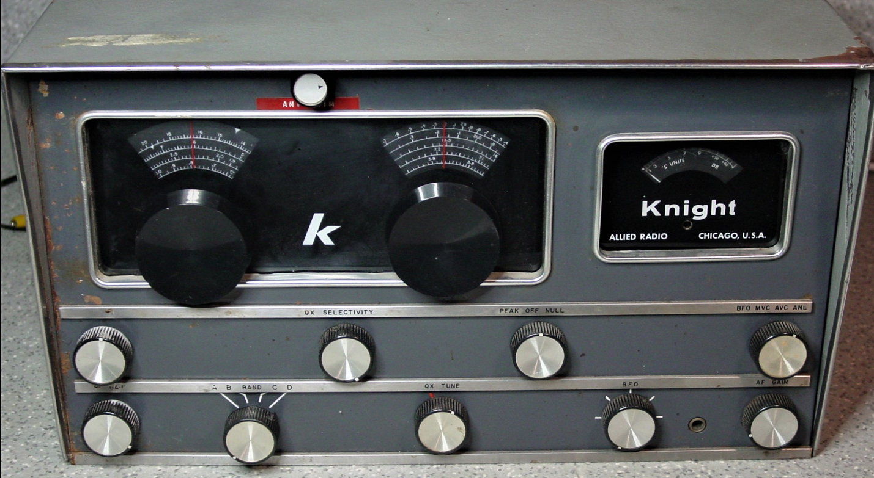

Knight D100 communications Receiver

The Six Most Common Amateur Radio Excuses

- Its less expensive than treatment
- My CQing isn’t habitual
- It helps me relax
- I started when I was young
- I’m just experimenting
- There isn’t any treatment

The Future Of Expanding Satellite Constellations

According to the IAU Center for the Protection of Dark and Quiet Skies, there are currently 4,276 operational constellation satellites orbiting Earth. While that may sound like a lot, there are 427,171 planned constellation satellites. So the problem will only get worse.

AN EXAMPLE:

Using the LOFAR radio telescope, we have detected radiation between radio frequencies of 110 and 188 MHz that is correlated with satellites of the SpaceX/Starlink constellation. These frequencies are well below the assigned transmission frequencies at 10.7–12.7 GHz. Broad-band emission was present over the whole observed bandwidth for some satellites, while others showed strong (from 10 Jy up to ~500 Jy) narrow-band signals at frequencies of 125, 135, 150, and 175 MHz. The presence of narrow-band emission differs between Starlink satellites at operational altitudes with those that were still actively raising their orbits, indicating possible differences in the operational state of the satellites, or differences between their hardware versions. We found that the flux density of the broad-band emission decreases with range, suggesting this emission is likely intrinsically generated and is detectable in 47 of the 68 Starlink satellites that were observed.
However, narrow-band radio emission at 143.05 MHz can be attributed to reflections of transmissions from the French GRAVES space surveillance radar, and while we know of no other radars operating at the detected narrowband frequencies or broad-band frequency ranges, confirmation that the observed narrow-band emission at other frequencies is intrinsic is required.

The narrow-band emission detected at 125, 150, and 175 MHz may be harmonically related, suggesting a local oscillator or clock signal operating at a frequency of 25 MHz. It is noteworthy that the narrow-band signals were only detected for satellites at the operational altitude. No such signals were seen for the satellites in orbit-raising phase, it is unclear if this effect is owing to operation or satellite version. The broad-band features are with high probability caused by other means, such as switched-mode power supplies, communication signals internal to the satellites, or some other electronic or electrical subsystem.

73,
Ken N8KH

Invisible Wire Discussion Continued

Last month we showed how small an amateur radio wire antenna could be regarding wire gauge. Here is some correspondance:

“Well this sent me down a rabbit hole, initially, just because I thought, “Isn’t most of the hobby/floral arranging brass wire going to be sold soft (annealed?)”

So I looked; and today I learned: Indeed, if tensile strength is the object, you want hard, not soft. There’s a ~2x difference in tensile strength for brass depending on temper. See here, ~930 N/mm² hard vs. 441 N/mm² annealed. Apparently, tensile strength goes up with zinc fraction, too, but conductivity goes down, e.g. here: 30% zinc gives tensile strengths 45-104 kPSI but conductivity 28% IACS (i.e. 28% of pure copper); 15% zinc gives 37% IACS but tensile strengths 39-90 kPSI. TANSTAAFL.
Pure copper, BTW, seems to be 28-58 kPSI depending on annealing.
I thought maybe bronze would be better, because some bronzes have higher copper fraction than typical brasses, but no. Marginally stronger than brass, but lower conductivity. Even 5% tin/0.1% phosphor bronze is only 15% IACS conductivity. 8% tin is 13% IACS, but ~20% stronger than the brasses. Can’t find sources for bronze wire less than 0.5mm in any case.
Beryllium copper is really strong, but I don’t want to mess with it, despite the fact that some alloys apparently have conductivity over 50% IACS (and others <20%).
Aluminum bronze really hard; you’d think with the principal constituents being aluminum and copper it would be very conductive, but it seems it’s no better than other bronzes (alloys are weird—two soft metals with high conductivity combine to make something very hard and much less conductive.)

Bottom line, IMO: if you’re eating the conductivity difference for brass in order to get more tensile strength, try to buy hard brass, not soft (it’s easy to anneal yourself anyway.)

//Hard copper would be nice, but a cursory search found no source of hard copper wire (sheet and tube, yes, wire, no). Makes sense, who wants wire that doesn’t bend easily.
//There are a lot of copper alloys.
//Some high-strength aluminum alloys, appropriately tempered, might offer a better tensile strength/conductivity trade than copper alloys, but one rabbit hole is enough for this evening”
--
Stephen Brown
Stephen.B.Brown@L3Harris.com

Inventions We Can’t Forget:

