High Band PA Test Plots

Output Noise Floor

The PA has about 64dB gain with a noise figure of about 6dB. Therefore, the output noise floor can be predicted to be -174+64+6 = -104dBm/Hz.

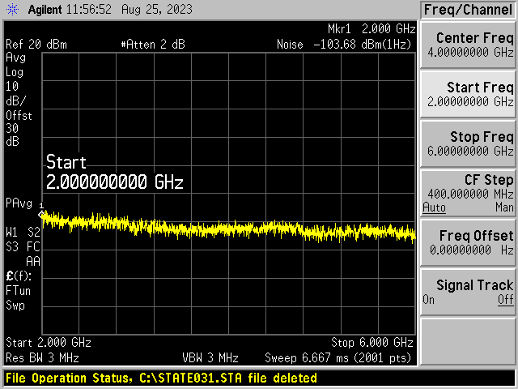

The plot above confirms this.

Small signal gain



The plot above shows the small signal gain at 28Vdd, 30Vdd and 32Vdd.



The plot above shows the large signal gain with -8dBm drive.



The plot above shows the input s11 for the Low Band PA when measured at 28V, 30V and 32V supply voltages and a -20dBm drive level. The plot shows that there is very little difference when the supply voltage is changed across this range.

Harmonic Distortion.

The harmonic distortion application for Windows is not currently working so the harmonic distortion plots were taken at 50W output and a 32V power supply.

