* Note: QB25/DB25 Car Transceiver can program via the hand mic within the given frequency (Quad-Band/Dual Band). The transmit/receive frequency of QB25 is 136-174/220-270/350-390/400-480.While the transmit frequency of DB25 is 136-174/400-480 and receive is 136-174/220-270/350-390/400-480.
* **Pro Version** contains an exclusive quad-frequency antenna. While **Standard Version** contains no antenna.
* To use the programming software:
* The first time when you try to program it via software:
* Install the Driver: (this step is necessary just for Windows 10, the programming cable has quipped with Windows 7/XP Driver, so it is no need to set it up for Windows 7/XP)
* Step 1: Double click the Driver

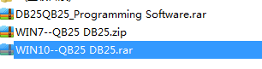 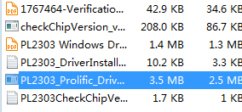

* Follow the instruction of the system until the set-up is completed.

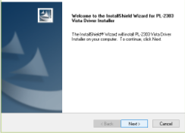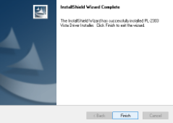

* Step 2: test if the Driver installed correctly
* Take out the programming cable, car charger cable, Car Transceiver
* First insert the programming cable to the USB Port, an automatic setup would be in the bottom right side or the screen.

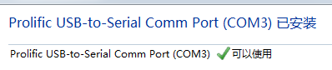

* Then you can check the set up status of the Driver in “My Computer-Settings-Device Manager”

1. If successfully, it would show like:



1. If failed, a yellow triangle would appear.



* If failed, please follow up the steps:

1. Left click the to select:



1. Right click to select---update driver systems
2. Select the last one from the above two choices---browse this computer to look for driver software
3. Select the last one-from the computer device driver list

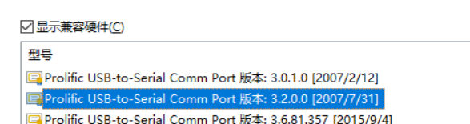

1. Choose the right version (the version you install in Step 1)
2. Pull out the programming cable and insert again, the cable would show like:



* Step 3: Install the programming software
* Open the software provided (DB25QB25_VIP_CPS)

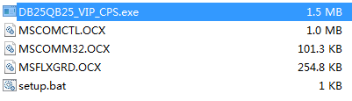

* Follow the instruction of the setup:

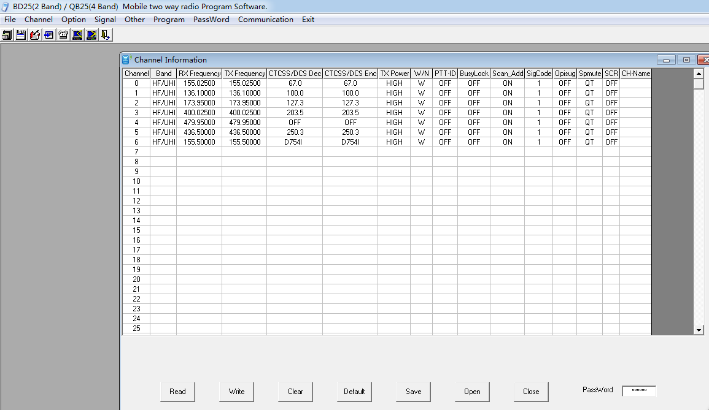

* Step 4: read and write/program

1. First, connect the car transceiver and turn it on. Please note that the software would select the COM# automatically. You can program your machine now.

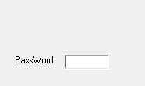

1. Please note the password on the right bottom and set it again (do remember to mark it down in case you would forget your password, we can do nothing if your machine is locked!!!)

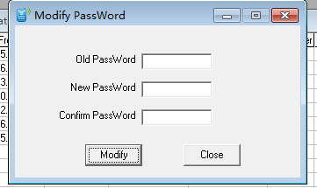

 You can use the support email in their website at <https://www.radioddity.com>. “Support”  They WILL get back to you in short order. Remember there is a large time difference, so don’t expect a response right away unless it is Midnight.

