Updated Instruction:
Open the updated software as following:
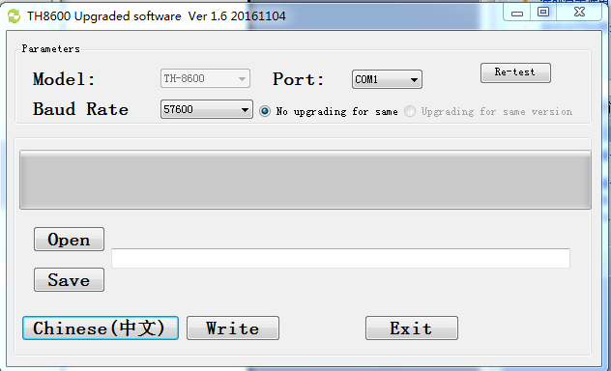
- press 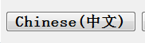can select language.
2.Plug in the cable, choose right Com port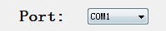
3.Press 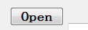and select the updated file.
4. disconnect Power supply first, then press PTT key in the hand mic at the same time, to connect the Power supply . （or Turn off the radio, press PTT key, at the same time, to turn on the radio, because we have two different lots of radio）The screen will flash, it means you have enter into the updated mode.
5.press 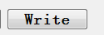, it will updated the radio/

Note: if try several time, updated failed.
- try to change the
change the Rate and try it again.( The lower Bps, the speed of updated will be more slow)
2. Cut off the power of radio, enter the updated mode again/

