Hardware requirements
PC with one spare USB port.
Radio internal soundcard or external interface.
For transceive, headset microphone, and Microsoft LifeChat LX-3000 chosen for this guide (excellent for FreeDV for the price).
Windows 10 is used for this guide.

Turn off audio from the radio as you are only interested in what comes from your headphones and it gets confusing when you have two audio sources.
Install the FreeDV software using the Windows installer.
Start FreeDV and plug in the headset.
Right click on the speaker icon at the bottom of the screen and select “Open Sound Settings” then left click “Sound Control Panel” to see this screen.

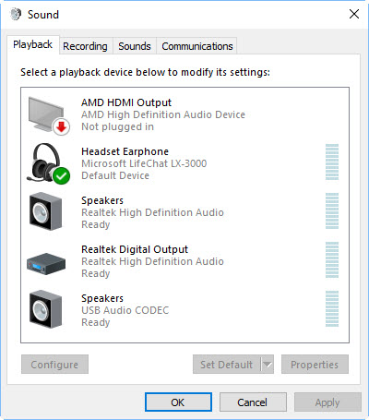
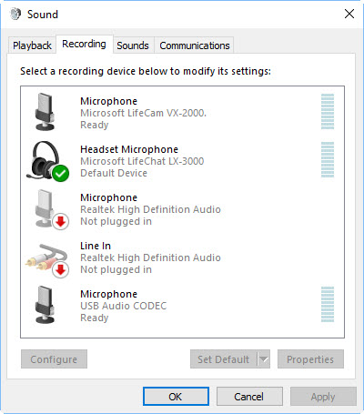
The examples shown are for an Icom transceiver using the Icom USB Audio Codec. This transceiver has a built-in sound card.
Yours will depend on the interface that you choose.
Left click on the Speaker icon at the bottom of the screen and select the headset microphone.
Right click on the Speaker icon click on “Open Volume Mixer” to see this screen.

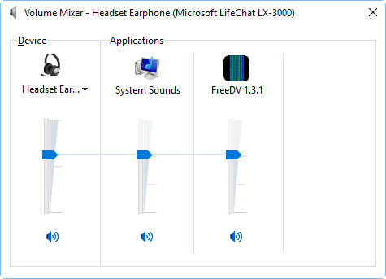

Start FreeDV and click on Tools>Audio config.
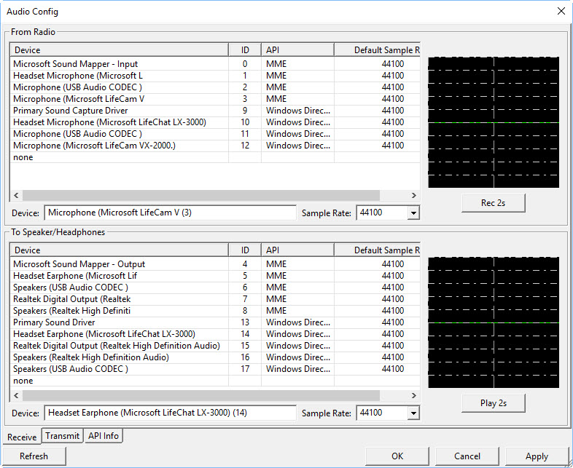
Use MME.

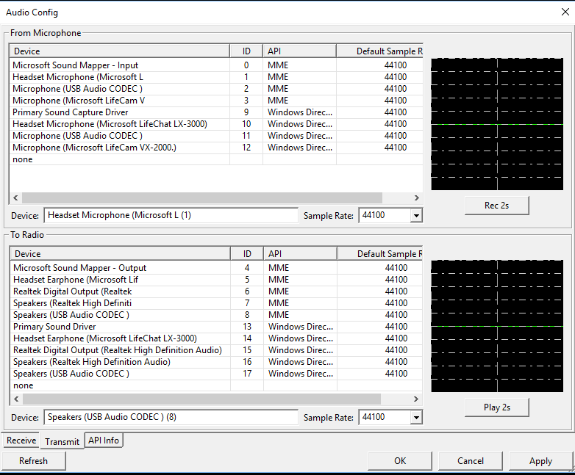
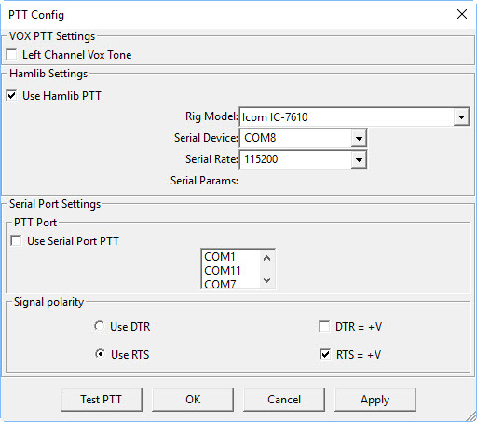
Select Tools> Options and Put your callsign, name and Grid Square into the Txt Msg field, leaving the others as defaults.
Click on the “Test PTT” button to confirm that you have everything correct.

Now, to the transceiver.
Turn off all DSP processing.
Turn the power down to around 20%.

Let’s get started.
Start FreeDV.
Plug in your headset – the program will default to your usual sound devices if you do not!
Click the “Start” button.
Don’t change the default settings at this stage.

Go to http://qso.freedv.org/ and log in (no password needed).
Set your transceiver to one of the recommended frequencies; what do you suggest? I have 7.180, 14.130, 21.180 and 28.330 as FreeDV memories in my radio.
If you see a station logged in, then call them.
If nobody has logged on, then enter your frequency and click on the PTT button to start calling.

