RS-232 Interface

PDW and the RS232 port
There is an increasing lack of PC's with serial ports these days. Decoding data networks such as Flex, POCSAG and Mobitex on a computer without RS232 port is only possible using the PC's soundcard. A USB to serial converter in combination with a 2 level interface won't work.
PDW doesn't use the normal RS-232 TxD/RxD lines, but uses the status lines (CTS, DSR, DTR). The 'abuse' of these lines for PDW purposes does not comply with the standard RS-232 protocol. If you have direct control over the serial port (i.e. through a physical port) you can sample these lines without a problem. If you use a USB to RS-232 converter, all serial communications goes through the converter's driver and PDW doesn't have direct control.
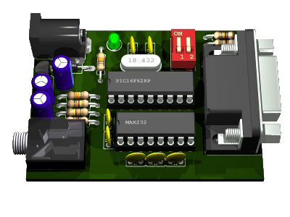
Data communication protocols like Flex, POCSAG and Mobitex use synchronous communication: a steady flow of ones and zeros. An RS-232 port is made for asynchronous communication: start bit, data bits, stop bit. The serial interface presented here takes care of conversion.
Using standard RS232 communication enables the user to
- Use a serial to USB converter of choice
- Use a serial PCMCIA or PCI card
- Run PDW on any Microsoft Windows version, including Vista and 7
- Run multiple instances of PDW on one PC (one user even reported 8 concurrent windows)
- Use a serial to Bluetooth adapter for wireless monitoring
- Monitor remotely by using a serial to Ethernet converter
- Run PDW in Wine under Linux (who's going to develop a Linux version of PDW?)

How does the interface work?
The new serial interface converts the synchronous (continuous) datastream into an asynchronous data signal with a start bit, 8 data bits and one stop bit. The interface works according to the next priciples:
- The incoming signal is sampled with 5 times the data speed. So e.g. a FLEX-1600 signal is sampled 8000 times per second
- The transitions from 0 to 1 and from 1 to 0 are used for bit synchronisation. Ideally, when receiving data, these 5 samples will be 11111 or 00000. If the 5 samples received are e.g. 11110 or 10000, resynchronisation needs to take place: one sample to the right resp. one sample to the left
- The majority of the 5 samples determines whether a 0 or 1 bit has been received
- When 8 bits have been received, these are sent to the serial port observing the standard RS232 protocol with 19200 bit/s , 8N1 (8 data bits, no parity bit, 1 stop bit)
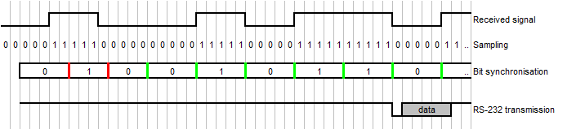
Apart from the bit synchronization, the interface doesn't contain any intelligence. The only thing the interface does is chopping a synchronous data signal into slices of 8 bits and sending these 8 bits asynchronously, i.e. packing them with start- and stopbits, according to the RS-232 protocol.

Interface Hardware
The new RS-232 interface is based on a cheap and common PIC16F628 microprocessor. It runs on a frequency of 18.432 MHz. This microprocessor has a built-in comparator ('2 level interface') and a hardware UART. To convert the output signal to RS232 levels (-10V / +10V), a MAX232 is used.
A standard RS-232 output is implemented, not a USB port. Next to the advantages mentioned earlier, the reason is that USB chips only come in SMD (Surface Mounted Devices). The circuit presented here only uses DIL (dual inline) components, making it easier to assemble the circuit board. Further to that, the circuit board is single sided, facilitating DIY production.
Using two DIP switches, 4 data speeds can be selected. Tentatively, the following speeds can be selected:
- 512 bit/s (POCSAG 512)
- 1200/2400 bit/s (combined setting for POCSAG 1200, 2400 and 1200/2400)
- 1600 bit/s (FLEX 1600)
- 8000 bit/s (Mobitex)
Other speeds can be programmed on request.
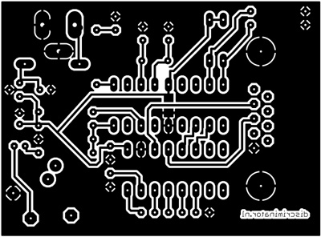
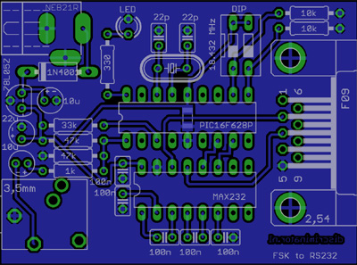
Circuit board design
Component placement

Changes PDW
To use this interface, you should download the latest version of PDW (version 3.x). In the 'Interface' settings in PDW from version 3.0, the user can now choose between 'Slicer' (the 'standard' 2 or 4 level interface) or 'RS232' (the new serial interface). It takes some getting used to this: changing between different data standards requires the user to change the settings on both the interface and in PDW.

Status
Since its introduction in September 2010, tens of interfaces have found their way to satisfied users worldwide. You can order a built and tested interface, or just the circuit board plus a programmed and tested microprocessor if you want to build the interface yourself.
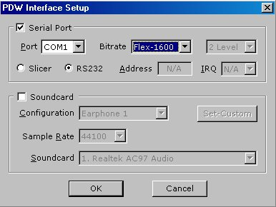
Prices and 'Buy Now'-buttons for instant ordering can be found on the Order page.

A final remark
Without the efforts of Peter Hunt to adapt PDW, this interface would not have existed. Therefore, for each sold interface or circuit board and microprocessor, a donation to him is made

© 2003-2011 discriminator.nl

